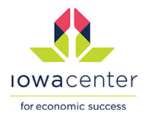
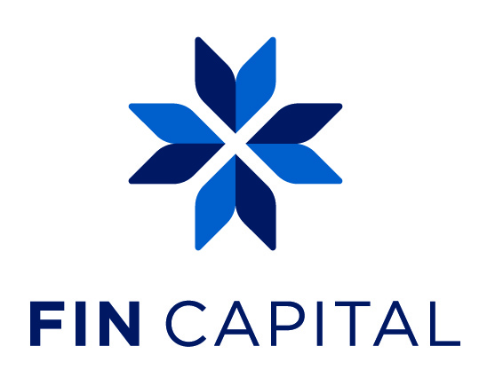

Contact:
Heidi Wessels, Director, FIN Capital
Iowa Center for Economic Success
hwessels@theiowacenter.org
515-283-0940 (o) // 515-360-3671 ©
www.theiowacenter.org

FOR IMMEDIATE RELEASE
Monday, August 14, 2017

Fin capitaL to host Angel Investing Boot Camp on september 25

The Aspirant Series inspires Iowa women to become articulate in Angel Investing
GREATER DES MOINES, IA August 14, 2017– FIN Capital, an initiative of Iowa Center for Economic Success, announced the date for the 2nd Annual Angel Investing Boot Camp. The event is open to all Iowa women who have an interest in angel investing, regardless of accreditation.
Aspirant Series: Angel Investing Boot Camp
Monday, September 25, 2017; 8:30AM to 5 PM
at Tero International

To register: click here. Limited seats are available and tickets are selling quickly!
FIN Capital, Iowa's women's angel investor network was established in 2016 by Iowa Center for Economic Success to grow women's wealth through angel investing. The network is made up of over 30 women from across the state of Iowa. FIN Capital is a network of discerning, professionally diverse women committed to investing in companies with strong leadership, unique solutions, scalability, and a clear exit strategy.
Susan Preston, Chair of Angel Resource Institute and Managing Partner of Seattle Angel Fund will return to lead the Boot Camp. “I’m thrilled to be coaching women in Iowa on the process of angel investing. Iowa is boldly moving forward in providing women an opportunity to reap the benefits of angel investing. The growth to over 30 members in less than a year shows that Iowa women not only want to participate but they are demanding their place at the table,” said Preston.

About Iowa Center for Economic Success: For more than 25 years, Iowa Center for Economic Success has been committed to empowering Iowans to pursue opportunities for financial success. Whether someone starts their relationship with us through our Education + Resources, Credit + Lending, or Advocacy + Networking programs, our commitment remains the same: empowering them to turn good ideas into strong plans that result in financial success www.theiowacenter.org
About FIN Capital: FIN Capital, an initiative of Iowa Center for Economic Success, formed in early 2016. The initiative’s goal is to grow women’s wealth through private angel investing. Members must be female, SEC Accredited, and residents of Iowa. http://theiowacenter.org/get-started/fin-capital/
# # #
If you would like more information about FIN Capital, please contact Heidi Wessels, Director of FIN Capital at 515-283-0940 or email at hwessels@theiowacenter.org.

