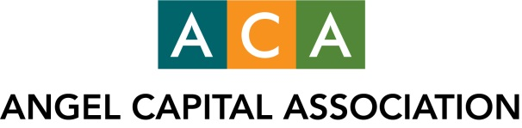

URGENT: Join ACA’s Campaign to Protect Angel Funding and the Startup Ecosystem We Support

The Securities and Exchange Commission (SEC) is poised to revisit the existing definition of an individual accredited investor to determine whether it “should be adjusted or modified for the protection of investors, in the public interest, and in light of the economy.” This review was required by Congress as part of the Dodd-Frank financial reform act, and will occur every four years starting in July of this year.

The current accredited investor definition includes individuals who have $1 million in net assets excluding a primary residence, or income of $200,000 if single and $300,000 if married. These thresholds were established in 1982, and have worked well to enable development a robust, accredited angel investing sector that operates in funding high-potential startups, with almost no fraud or abuse.

Nonetheless, there are powerful organizations working aggressively to see these thresholds increased in line with “inflation,” as a form of investor protection. Many advocate increasing the net worth requirement to $2.5 million and annual income to $450,000. Their efforts, if successful, would result in nearly 60 percent of current accredited investors being shut out based on numbers from the SEC itself.

Number of U.S. Households that Qualify as Accredited
Investors Based on 2010 Net Worth*
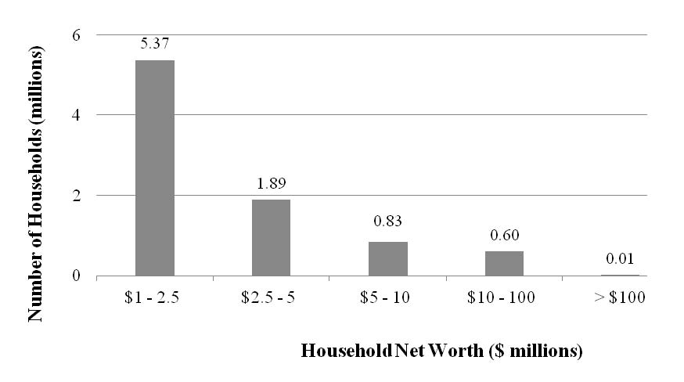
*SOURCE: SEC Release No. 33-9415, Eliminating the Prohibition Against General Solicitation and General Advertising in Rule 506 and Rule 144A Offerings, Economic Analysis, page 75.

In our January survey of ACA members, found that 25% of our 12,000+ members would become ineligible if these thresholds were raised. Outside of California, Massachusetts and New York, that increases to nearly a third. Such a drop would be devastating to angel groups and the early-stage companies we support at the most vital and fragile point in their development.

Now that general solicitation is broadly available for private company offerings under Rule 506(c), some consumer advocates and others advocate extreme restrictions on who may participate in private offerings – limiting it to just the most wealthy three percent of all households. Some argue that the definition should also be indexed for inflation on an ongoing basis – thus practically ensuring that even those who are upwardly mobile stand little chance of qualifying as accredited investors in the future.

The SEC is weighing these opposing views.

We all recognize that such a dramatic drop in the number of accredited investors would cause dire harm to the innovation economy and its role in job creation that angels – and only angels – support at these earliest stages.

SEC officials have indicated they will consider alternative criteria for meeting the accredited investor definition. These criteria may include: possession of professional certifications or degrees; ownership of a specific amount of investment securities; membership in an established angel group, or reliance on registered intermediaries. ACA supports this approach for individuals who do not meet the financial thresholds to prudently broadening the definition in this manner.

ACA’s top priority is to ensure the SEC does not cause irreversible damage to angel investing – and the early-stage companies we support that create most new jobs nationwide -- by imposing arbitrary inflation-adjustments that essentially provide no investor protection in a market with minimal fraud risk, and a variety of existing remedies for the rare “bad actor” that appears.

You can read ACA’s comment letter to the SEC on this issue at: www.sec.gov/comments/s7-06-13/s70613.shtml. It is also available on our website at: www.angelcapitalassociation.org/aca-public-policy-protect-angel-funding/.

WE NEED YOUR HELP

We urge you to join us in asking the SEC to maintain the existing $1 million and $200,000 limits, and to further expand the capital pool for these early-stage companies by creating ways to qualify individuals with requisite sophistication to invest in private offerings, even if they may not meet the thresholds.

ACA has prepared template letters you may send to the SEC, to your Congressional representatives, and to local officials who are part of the vital ecosystem supporting startups and the jobs they create. Feel free to revise and/or add your personal thoughts. All of the templates are available at www.angelcapitalassociation.org/aca-public-policy-protect-angel-funding/.

A healthy early-stage capital market is critical to our economy, and serves the public interest by creating jobs and enabling innovative, talented entrepreneurs to create jobs and wealth.

Please join us in supporting this vital issue, and making the voice of angels clearly heard.

Sincerely,

Marianne Hudson
Executive Director
Angel Capital Association
mhudson@angelcapitalassociation.org

